FailSafe

Software Requirements Document

### Autumn Jackson

### Bre Tucker

### Jordan Gill

### 9/22/2016

Change History:

|  |  |  |  |
| --- | --- | --- | --- |
| Version | Summary | Author | Date |
| 0.1 | Initial Write-up | Jordan Gill | 9/21/2016 |
| 0.2 | Added to functional and non-functional requirements | Jordan Gill | 9/21/2016 |
| 0.3 | Added Class diagram and descriptions | Autumn Jackson | 9/22/2016 |
| 0.4 | Added Activity diagrams and descriptions | Autumn Jackson | 9/22/2016 |
| 0.5 | Added Use case diagrams and descriptions | Bre Tucker | 9/22/2016 |
| 0.6 | Reformatting | Jordan Gill | 9/22/2016 |

Table of Contents

1. Introduction 1

1.1 Motivation/purpose 1

1.2 Scope 1

1.3 Goals 1

2. Project Description 2

2.1 Add Classes and Assignments 2

2.3 What-If 2

2.5 Map 3

2.6 Multiuser Support 3

3. System Requirements 3

3.1 Functional Requirements 3

3.2 Non-Functional Requirements 4

5. Diagrams 6

5.1 Use Case Diagrams 6

5.2 Class Diagram 7

5.3 Activity Diagrams 8

# 1. Introduction

## 1.1 Motivation/purpose

The purpose of the application FailSafe is to give students the ability to more actively track their grades and overall GPA and thus stay on top of their class performance. The motivation behind developing FailSafe for mobile devices is to increase accessibility to students, who are often on the go and not always near a computer, which in turn will ideally encourage use of the application to track grades and assignments.

## 1.2 Scope

By the end of development, FailSafe will be able to accurately calculate the grades, weighted and unweighted, of any and all assignments, quizzes, and exams. The application will also allow users to drop grades and recalculate their overall grade for a course, as well as feature a “What If” option that will give users the opportunity to calculate potential grades with hypothetical assignment scores. As a matter of course, FailSafe will also be able to keep track of multiple classes and the coursework and grades associated with them.

## 1.3 Goals

The goals for the first version of the project are to implement the class and coursework tracking features and the grade calculator. The goal of the second version of the application is to include a functional in-app calendar to which assignments can be automatically added. A calendar native to the application will allow for more information about each assignment to be displayed, as well as allowing for filtering options such as displaying work for only once class on the calendar as opposed to all classes. Finally, the goals for a third version include multiuser support, professor-specific features such as allowing professors to submit class-wide assignments or grade weights, and an interactive map to assist users in finding specific buildings.

# 2. Project Description

## 2.1 Add Classes and Assignments

First and foremost, FailSafe will allow users to input their class schedules and any coursework associated with each class. Users will also be able to add grade weights for each course and due dates for all assignments. In addition to basic assignments such as homework and readings, students will able to enter and track exams and quizzes, including the related dates.

2.2 Save and Calculate Grades

The application will save any inputted grades, unless removed by the user, to be searched and viewed at any time. These saved grades are then used to calculate a running overall grade for the class in question. If grades have been entered for the course, then the grade will automatically be calculated with the submitted weights. Otherwise, the calculated score will be a basic unweighted average of the saved scores.

## 2.3 What-If

This feature will allow students to calculate potential grades based on hypothetical scores. The feature will extend to both individual classes as well as overall semester GPA calculation based on the courses saved in the application.

2.4 Teacher Tools

Though FailSafe is primarily intended to be used by students, various tools can be added to facilitate use for educators. These features will include the ability for the professor to add grades and assignments to the class as a whole, so that students in the class will not have to do so individually.

## 2.5 Map

To aid students in finding the classes they have inputted, FailSafe will also provide an interactive campus map. Using GPS, the application will track the user with a marker on the map and lead them to the desired building. If no GPS is available, then a highlighted path from a position of the user’s choosing to the end point will be shown.

## 2.6 Multiuser Support

Ultimately, FailSafe will be able to support multiple users and allow them to interact with one other in various ways. User will theoretically be able to chat with other users, share notes and study materials, and interact with professors using the app. To this end, a username and password system would be implemented.

# 3. System Requirements

## 3.1 Functional Requirements

The application will be expected to do the following:

* Allow users to add, remove, and keep track of individual courses.
* Allow users to add, remove, and keep track of all coursework, including homework, readings, exams, and quizzes, associated with each class.
* Keep track of due dates for each assignment.
* Allow users to add grade weights for each course.
* Allow users to add, save, and calculate weighted and unweighted grades for each course.
* Allow users to calculate overall GPA using the submitted classes.
* Allow users to calculate potential grades using the “What-If” feature.
* Automatically add coursework to calendar and display relevant information (to be implemented if time permits).
* Allow users to share study materials with other students in their class (to be implemented if time permits).
* Display a campus map to assist users with finding buildings (to be implemented if time permits).

## 3.2 Non-Functional Requirements

The application will be expected to perform in the following manner:

* Grade calculation should be performed quickly and accurately
* The application should work smoothly on all Android devices (other mobile device support to be added at a later time).
* Username and password combinations will be used to ensure basic security and privacy for all users.
* The application should be user friendly and intuitive to use. A user should be able to use the application to its full potential immediately upon downloading.
* The application should be easily modifiable to expand to other universities.
* The application will be largely self-contained and should not draw heavily on the target device’s resources.
* There can be no unhandled exceptions from incorrect user input.
* All menus must have a consistent format.
* During a system restart, the system will return to a functioning state.

# 5. Diagrams

## 5.1 Use Case Diagrams

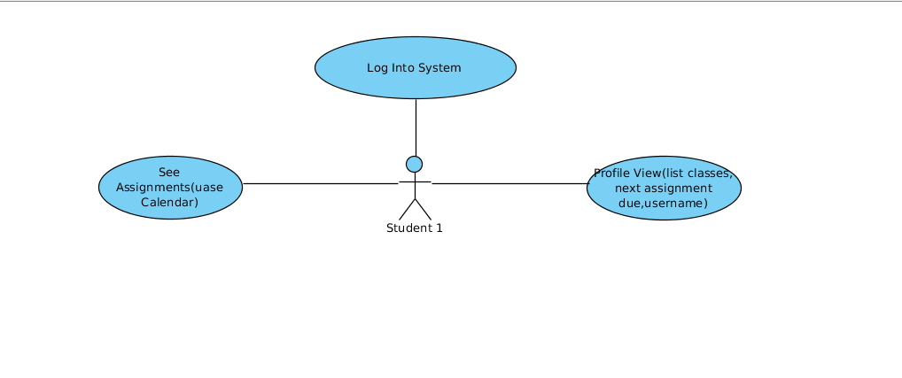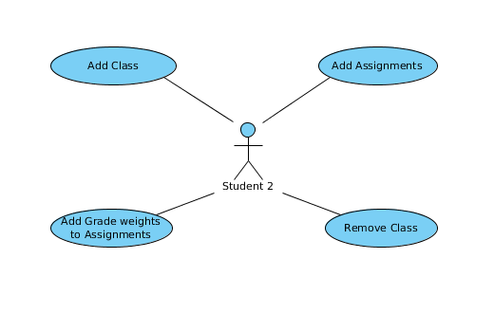

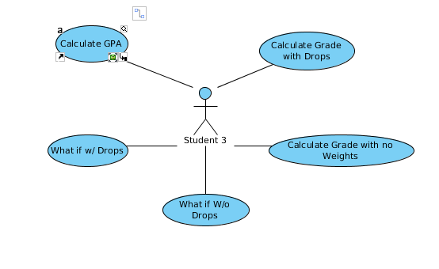

Our main Actor in FailSafe is the student, in the future we would like to add a professor as an additional user. The user is able to log into the system to get to the profile view. From this view he/ she is able to view the list of classes, their next assignment, their due date, and username. The student is also able to see assignments via the calendar. From the profile view, a student is able to add a course to their profile. When a course is added the student is then able to add assignments for that course, and also add grade weights to their assignments. The student is also given the option to remove a class if he/she would like. Once a student adds a course and adds the assignments and weights he/she is given the options to see their calculated grades. The user is also given the option to see a calculated grade with the option to choose a calculated grade with no drops and one with drops. They are also given the opportunity to generate a calculated grade with a what-if function where the user can calculate a grade with chosen scores to see their progress in the course before all assignments are graded. Finally, the user is given a option to see their calculated GPA once the scores have been all inputted.

## 5.2 Class Diagram

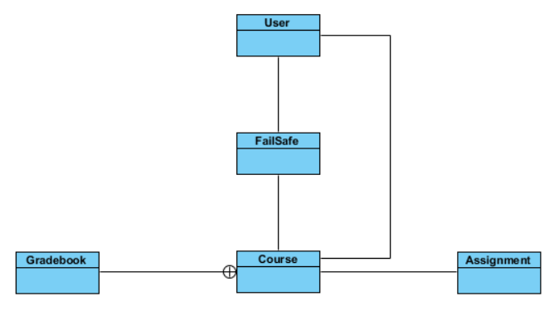

Our system consists of five classes. User contains the user’s username and password as well as a list of their classes, represented by one Course object per class. The Course class holds the course name and ID and also an instance of the Gradebook class and is the only way for the system to liaison with Gradebook. Gradebook does most of the heavy-lifting for the system. It keeps track of ALL the assignment grades. Anything dealing with those grades—storing, retrieval, calculations, modifying, etc.—is done here. Assignment holds all descriptive information for a user’s assignment. The main driver of the system is the FailSafe class. It is with this class that the user interacts and FailSafe is responsible for taking the user’s input and request and directing them to their appropriate destination.

## 5.3 Activity Diagrams

We have five activities within the FailSafe system: creating a user, login, adding a class, adding an assignment, calculating a grade, and removing a class.

**Create User.** When the user opens the app, they’re presented with a screen with username/password boxes and a “Create User” button. Since at this point the user doesn’t have a username or password, they will choose the “Create User” button. It takes them to a new screen where they will create a username and password. Once they tap the “Add User” button, FailSafe creates a User object where it stores the credentials then returns the User to the login screen.

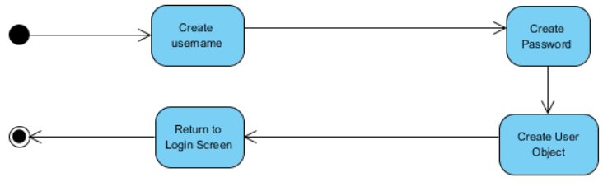

**Log Into System.** After the user creates login credentials, they need to use them. The first action of the Log Into System activity is the user opens the app, but they just created an account in the above activity, so they are already on the open screen where FailSafe prompts them with the username/password boxes. The user enters their username and password and hits enter. Failsafe checks the username first. If it is incorrect, FailSafe prompts them for a new username and password. If it is correct, Failsafe then checks whether the password stored with that username matches the one submitted. If it does not, FailSafe prompts for a new username and password. Otherwise, the user is taken to the first screen within Failsafe.

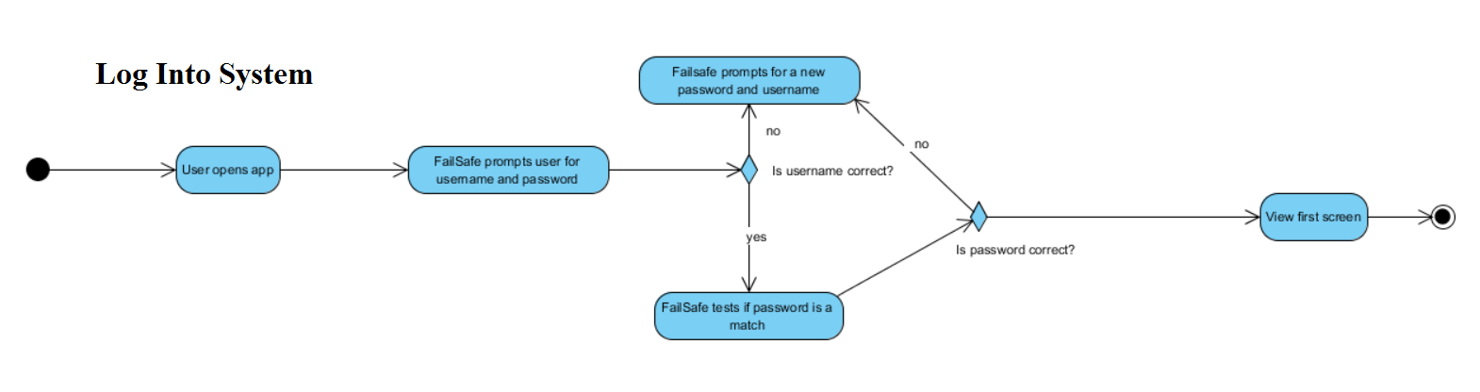

**Add Class.**Next, the user needs to add a class to FailSafe. They select “Add Class” on the welcome screen and are presented with a form page prompting them for the course information. Behind the scenes, FailSafe creates a Course object to store the information the user will provide. The user enters the course name (stored as *name*), course number & section (stored as *course_id*), the weights for the various types of assignments in the class (added to their appropriate places in Gradebook), and indicates which assignments, if any, have the option of dropping grades from the average and how many (sets appropriate flags within Gradebook). Once the user has entered all the required information, FailSafe adds the Course object to the user’s class list in their User object.

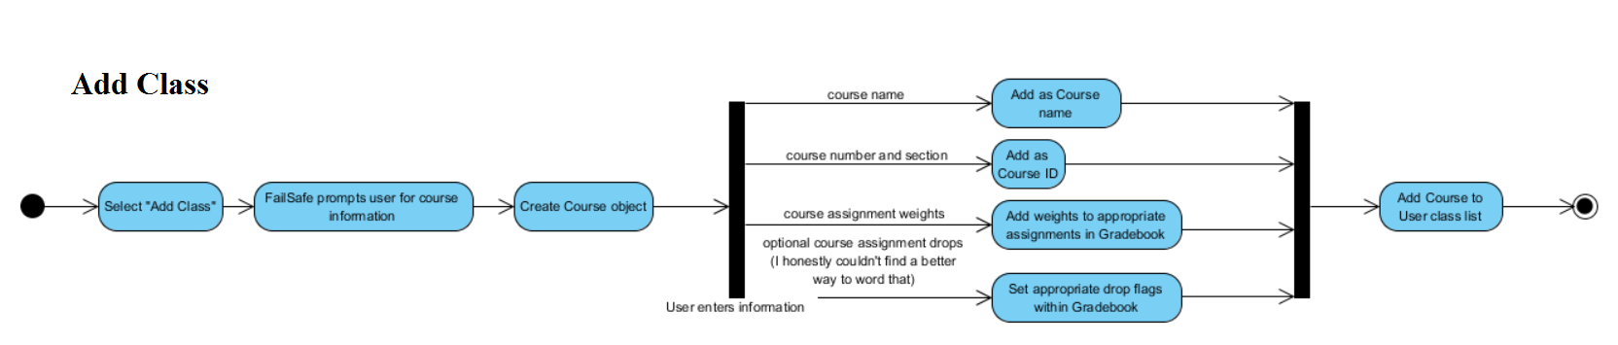

**Add Assignment.** Now that they have added a class, the user needs to enter their assignments or they will not be able to calculate any grades, and that is FailSafe’s main objective. To add an assignment to a class, the user first selects the desired class from their class list and from that class’s screen chooses “Add Assignment”. Similar to the Add Class activity, FailSafe creates an Assignment object and the gives the user a form page to fill out with the assignment information. The user enters the assignment’s name, due date, type (test, reading, project, etc.), and a description of the assignment. All of these entries are then stored in their designated places within the Assignment object. FailSafe assigns the assignment a number based on how many assignments of that type have been added before it, then adds the assignment into the calendar and exits the activity.

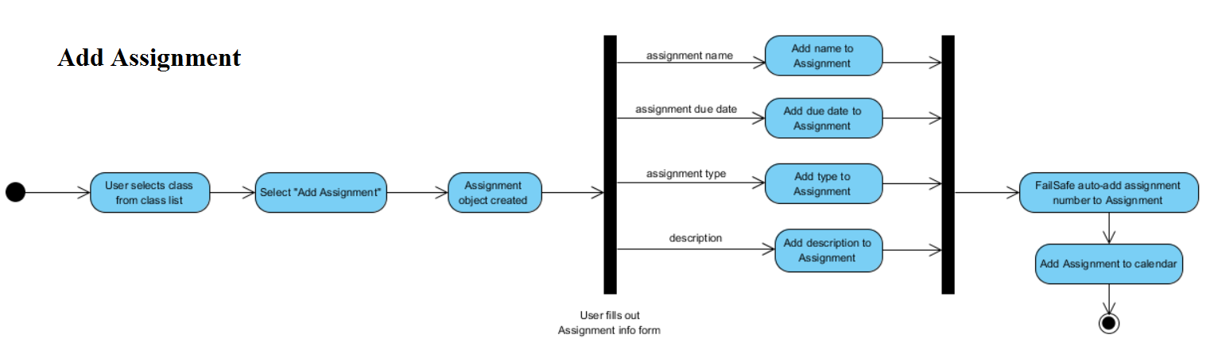

**Calculate Grade.** User selects the class for which they wish to calculate an average from their home screen. On that class’s screen they select “Calculate Grade”. The user is then presented which two options: they can calculate their actual grade as it stands at that moment or they can calculate their hypothetical grade in a “What If?” scenario.

Choose “What If?”: Failsafe displays all of the user’s current grades for all of their assignments and the user chooses which grades they wish to change. FailSafe then calculates and displays their temporary hypothetical grade.

Choose to calculate current grade: The user again is presented with two options. They can choose to calculate the average for a particular assignment set, in which case FailSafe will average the grades in that set with no weight applied. Or the user can choose to calculate their complete grade as it stands and FailSafe will average their scores with all weights and drops applied.

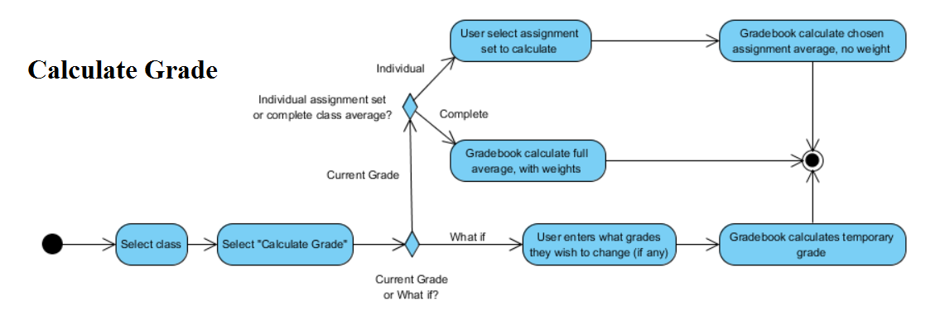

**Remove Class.** The user selects the class they wish to drop and chooses “Delete Class” from the class’s screen. FailSafe checks to see if the class actually exists in the user’s class list. If not, it gives the user an error message and returns to the main screen. If it is indeed a valid class, FailSafe removes the Course object from the user’s class list and removes its button from the main screen.

